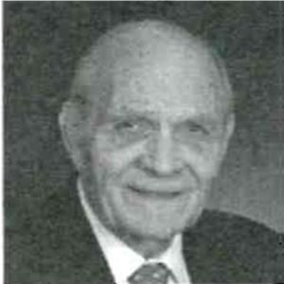
Dr. Larry White
Half of What You Know About Orthodontics is Wrong
Codes: 140; Other
CE Hours: 4.5 Hours

The biggest problem with the acquisition and application of new ideas and techniques is not the actual learning of them, rather the forgetting and using of older and more habitual thoughts. This reluctance to unlearn old lessons is known as path dependence, which broadly means history matters. Path dependence explains how the set of decisions one faces for any given circumstance is limited by the decisions one has made in the past, even though past circumstances may no longer have relevance. Unfortunately, much of orthodontic knowledge and practice still depends on path dependence. This lecture intends to dispel some of those commonly held beliefs by those who practice clinical orthodontics and suggest some alternative and more beneficial diagnostic, treatment planning and therapeutic protocols. At the conclusion of this lecture, attendees will have some of their most common and cherished beliefs challenged and disproved and they will have knowledge of preferable alternatives that will benefit them and their patients.
Larry W. White, DDS, MSD, graduated from Baylor Dental College. He then served two years in the United States Air Force Dental Corps before moving to Hobbs where he practiced general dentistry for five years. He returned to Baylor Dental College and received a graduate degree in orthodontics. He practiced orthodontics in Hobbs for 31 years and then began an academic career by starting the University of Texas Health Science Center in San Antonio’s first graduate orthodontic program. Dr. White has published over 100 professional articles, authored several books about orthodontics and edited numerous professional publications. Dr. White continues to practice orthodontics and teach in the Orthodontic Department at Baylor Dental College.

